#include <iostream>

#include <iomanip>

using namespace std;

int main() {

int count = 1;

for (int i = 100; i <= 1000; i++) {

if (i % 5 == 0 && i % 6 == 0) {

(count++ % 10 != 0) ? cout << setw(4) << i : cout << setw(4) << i << "\n";

}

}

}



#include <iostream>

using namespace std;

int main(){

double e = 1;

double item = 1;

for (int i = 1; i <= 100000; i++) {

item = item / i;

e += item;

if (i == 10000 || i == 20000 || i == 30000 || i == 40000 || i == 50000 || i == 60000 || i == 70000 || i == 80000

|| i == 90000 || i == 100000)

cout << "When i = " << i << ", e = " << e << endl;

}

}

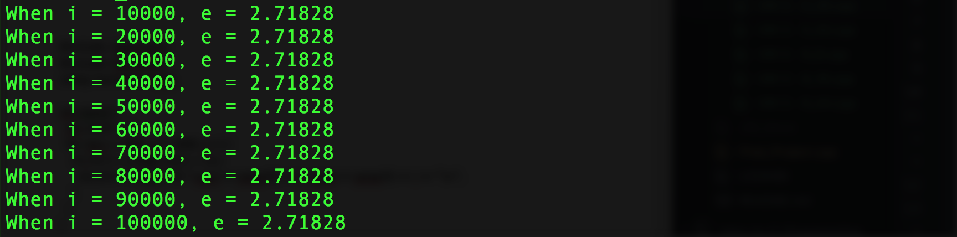

#include <iostream>

#include <iomanip>

using namespace std;

int main() {

double deposit, perYie, matPer;

cout << "Enter the initial deposit amount: $";

cin >> deposit;

cout << "Enter the annual percentage yield: ";

cin >> perYie;

cout << "Enter the maturity period (number of months): ";

cin >> matPer;

cout << "Month CD Value\n";

for (int i = 1; i < matPer; i++) {

deposit = deposit+deposit\*(perYie/1200.00);

cout << setw(2) << i << setw(10) << deposit << endl;

// cout << deposit << endl;

}

}

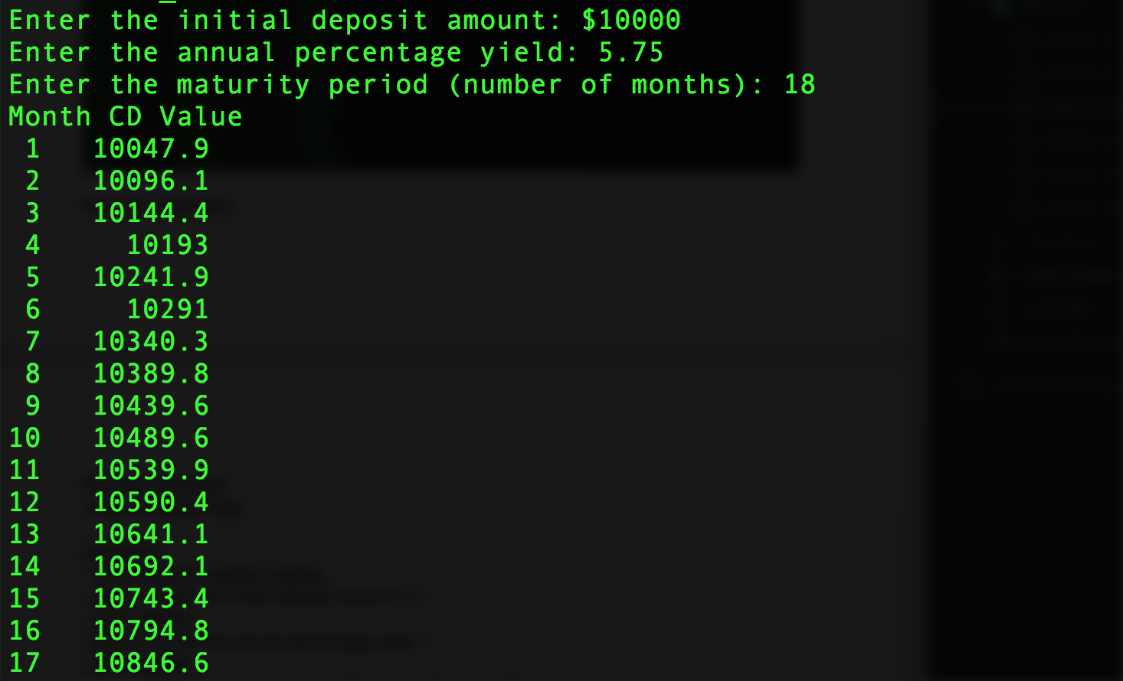

#include <iostream>

#include <iomanip>

#include <cmath>

using namespace std;

double feetToMeters(double feet) {

return 0.305 \* feet;

}

double metersToFeet(double meters) {

return (1 / 0.305) \* meters;

}

int main() {

cout << setw(15) << "Feet" << setw(15) << "Meters" << setw(15) << "|" << setw(15) << "Meters" << setw(15) << "Feet" << endl;

cout << "---------------------------------------------------------------------------------------" << endl;

double feet = 1; double meters = 15;

for (int i = 1; i <= 10; feet++, meters += 5, i++) {

cout << setw(15) << feet << setw(15) << feetToMeters(feet) << setw(15) << "|" << setw(15) << meters << setw(15) << metersToFeet(meters) << endl;

}

}

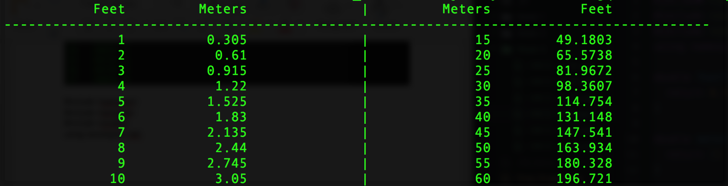

#include <iostream>

#include <iomanip>

#include <ctime>

#include <cmath>

using namespace std;

void printMatrix(int n);

int main() {

srand(time(0));

printMatrix(3);

return 0;

}

void printMatrix(int n) {

for (int i = 0; i < n; i++) {

for (int j = 0; j < n; j++) {

cout << rand() % 2 << " ";

}

cout << endl;

}

}

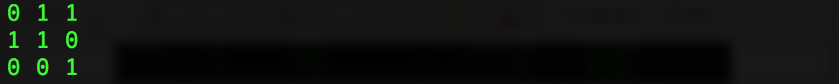

#include <iostream>

#include <string>

using namespace std;

int count(const string& s, char a);

int main() {

string s;

char a;

cout << "Enter a string: ";

getline(cin, s);

cout << "Enter a character: ";

cin >> a;

cout << a << " appears in " << s << " " << count(s, a) << " times" << endl;

return 0;

}

int count(const string& s, char a) {

int counter = 0;

for (int i = 0; i < s.length(); i++) {

if (s[i] == a) counter++;

}

return counter;

}

